Chapter 14, Problem 88.

Use PSpice to generate the magnitude and phase Bode plots of V_{o} in the circuit of Fig. 14.105.

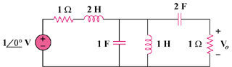

Figure 14.105
For Prob. 14.88.

